### Graduation Hat Box

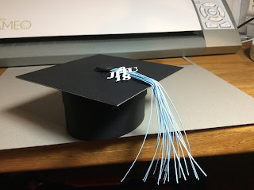

Graduation Hat Box

I am so proud of my husband. He graduated this week from Johns Hopkins University with a Master's Degree in Applied Economics. I made him this box to celebrate his lifelong ambition of getting an advanced degree in Economics.  
  
I used cardstock and chipboard to construct this box.

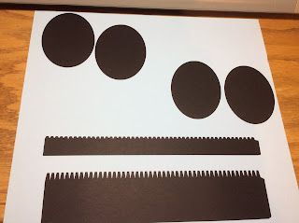

There are two size ovals. Make sure that you keep them together. The smaller ovals are for the bottom and the larger ovals are for the top of the box.

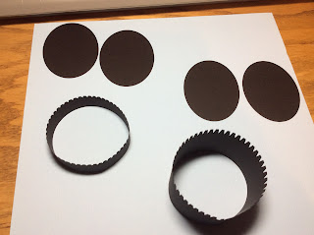

The narrow piece (rim) forms the top of the box. Make it into a circle and glue. Repeat for the other wider piece.

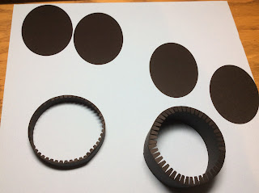

Bend down the tabs as shown above.

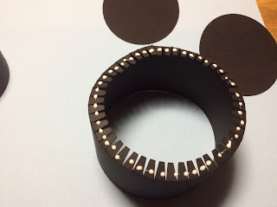

Apply glue to all of the tabs.

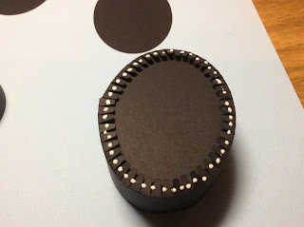

Put the seam on the side of the box and add the corresponding oval which is - large oval & small rim - for the top of the box. Place one of the larger ovals inside the box and the other on the outside.

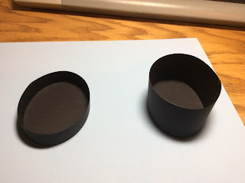

Repeat for the bottom of the box which is - small oval & large rim.

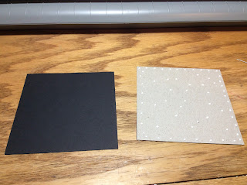

Make the top of the hat by sandwiching chipboard between two pieces of black squares.

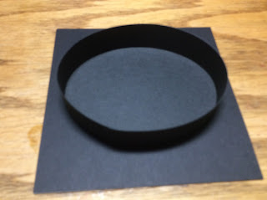

Glue the top of the box to the center of the square.

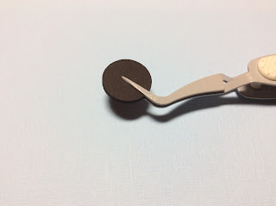

Glue six circles together to make the button on the top of the hat.

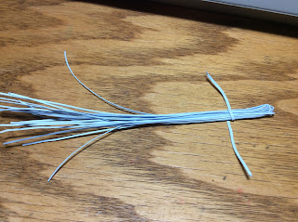

Make the tassel. Take the strips of paper and fold in half. Tie them together with the short strip of paper.

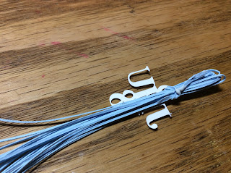

Thread the charm through the short strip of paper and glue at the back point.

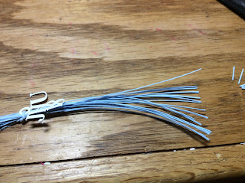

Cut the tassel to make it even.

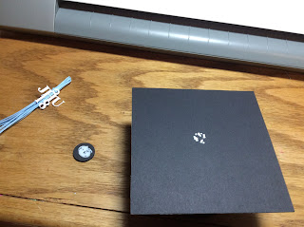

Put glue in the center of the hat and add the tassel. Put glue on the button and put on top of the tassel.

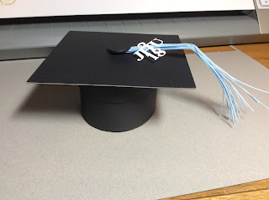

Completed Hat Box.